


Experiment No.: 1

Title:

8-Puzzle Problem using Python

Aim:

To solve the 8-Puzzle problem using the A* Search algorithm in Python.

Apparatus / Software Required:

Computer or Laptop

Python 3.x

IDLE / VS Code / PyCharm (Any Python IDE)

Windows Operating System

Procedure:

Open the Python IDE.

Create a new Python file.

Write the Python program for the 8-Puzzle problem.

Save the file with the .py extension.

Run the program.

Enter the initial puzzle state (if required).

The program applies the A* Search algorithm.

The shortest path to the goal state is displayed.

Verify the output.

Close the program.

Program:
from queue import PriorityQueue

goal = [[1,2,3],[4,5,6],[7,8,0]]

def heuristic(state):

h = 0

for i in range(3):

for j in range(3):

if state[i][j] != goal[i][j]:

h += 1

return h

def find_blank(state):

for i in range(3):

for j in range(3):

if state[i][j] == 0:

return i, j

def neighbors(state):

x, y = find_blank(state)

moves = [(-1,0),(1,0),(0,-1),(0,1)]

result = []

for dx, dy in moves:

nx, ny = x+dx, y+dy

if 0 <= nx < 3 and 0 <= ny < 3:

new = [row[:] for row in state]

new[x][y], new[nx][ny] = new[nx][ny], new[x][y]

result.append(new)

return result

start = [[1,2,3],[4,0,6],[7,5,8]]

pq = PriorityQueue()

pq.put((heuristic(start), start))

visited = []

while not pq.empty():

_, state = pq.get()

if state == goal:

print("Goal Reached:")

for row in state:

print(row)

break

visited.append(state)

for n in neighbors(state):

if n not in visited:

pq.put((heuristic(n), n))

Output:
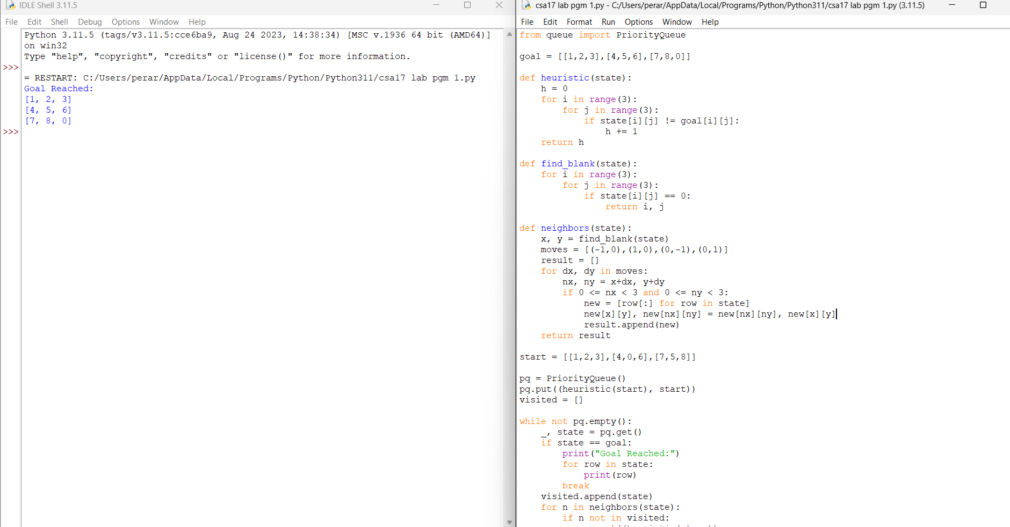

Result

Thus, the Python program to solve the 8-Puzzle Problem using the A Search algorithm* was implemented successfully, and the desired output was obtained.

